**Unveiling Market Insights: Analysing Spending Behaviour And Identifying Opportunities For Growth**

1 INTRODUCTION

* 1. Overview

Wholesaling or distributing is the sale of goods  to retailer to [industrial](https://en.wikipedia.org/wiki/Manufacturing), commercial, [institutional](https://en.wikipedia.org/wiki/Institutional) or other professional businessman to other wholesalers (wholesale businesses) and related subordinated services.  Wholesaling is buying goods in bulk quantity, usually directly from the manufacturer or source, at a discounted rate. The retailer then sells the goods to the end consumer at a higher price making a profit.

The consumption and production of marketed food are spatially separated. Production is primarily in rural areas while consumption is mainly in urban areas.In today's highly competitive business landscape, gaining deep market insights is essential for businesses to thrive and grow. This project aims to analyze customer spending behavior and identify opportunities for growth by leveraging data analytics and data-driven decision-making.

* 1. Purpose

Conducting market research allows companies to gain insight into their customers, competitors, and industry trends. By doing so, companies can identify opportunities to develop new products, expand into new markets, and improve their marketing efforts

1. Problem Definition & Design Thinking

Problem Understanding, also known as Problem Definition or Problem Identification, is the initial and critical phase of any data analysis or problem-solving process. It involves gaining a clear and comprehensive understanding of the problem at hand, its context, scope, and objectives.

* 1. Empathy Map

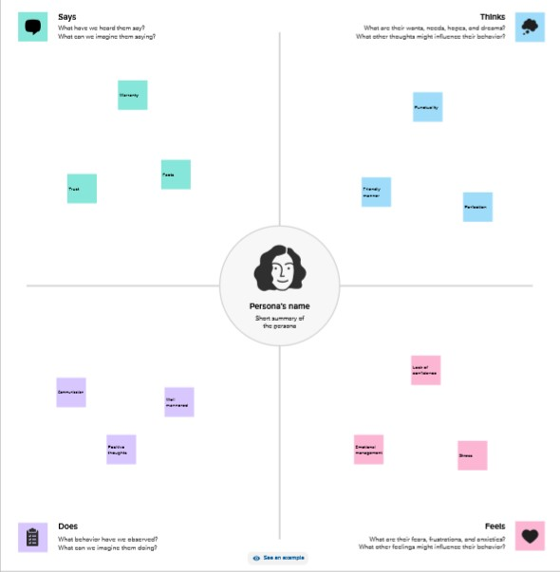

2.2 Ideation & Brainstorming Map

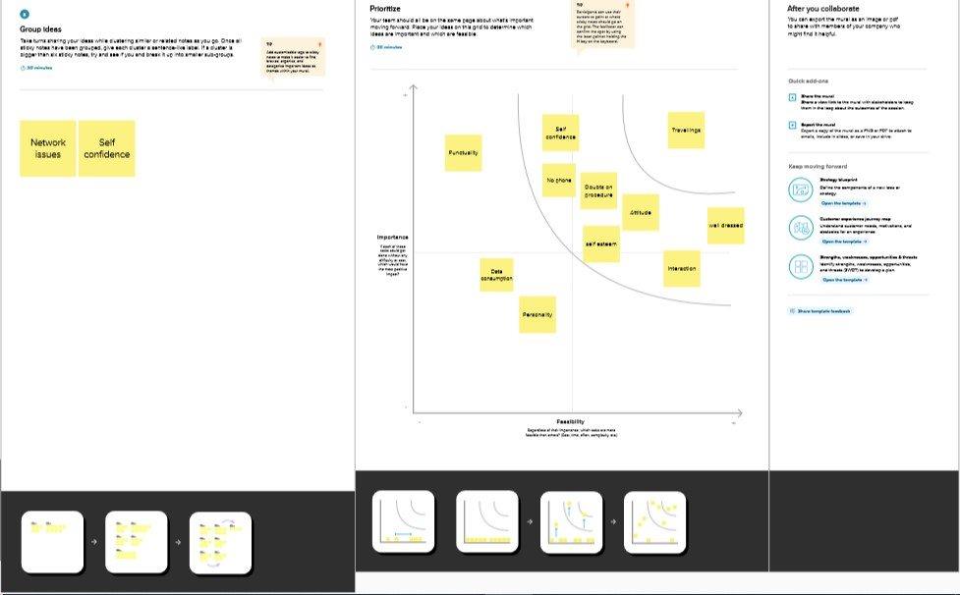

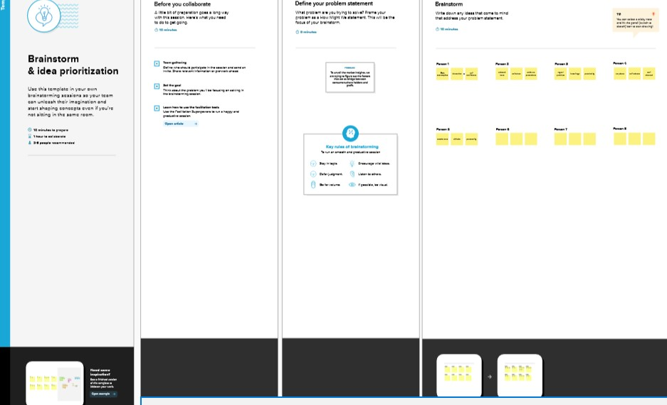

1. RESULT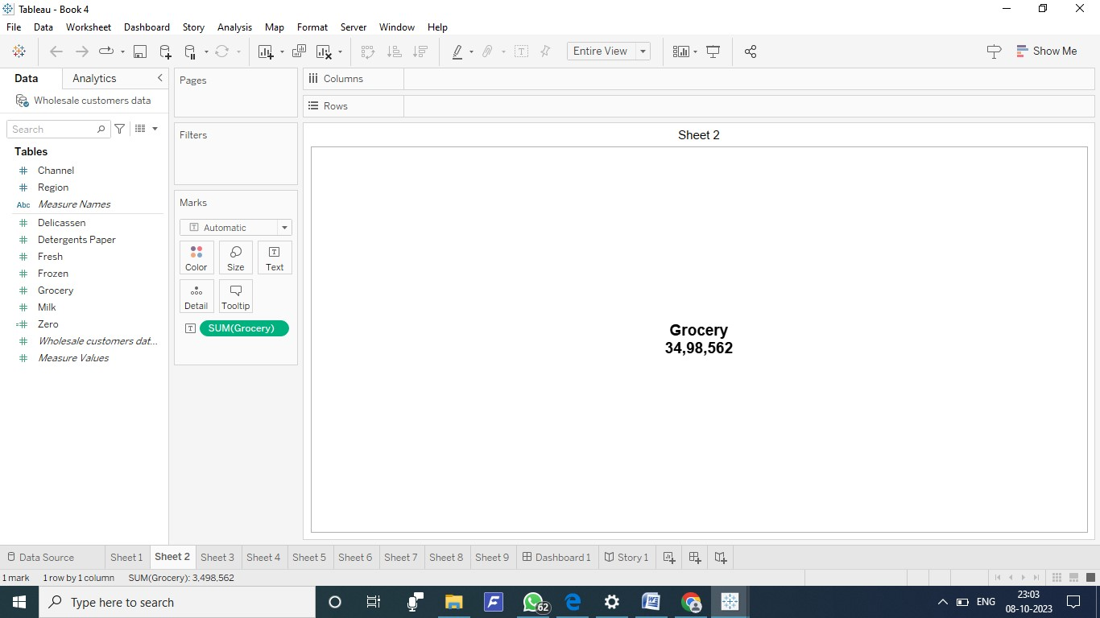

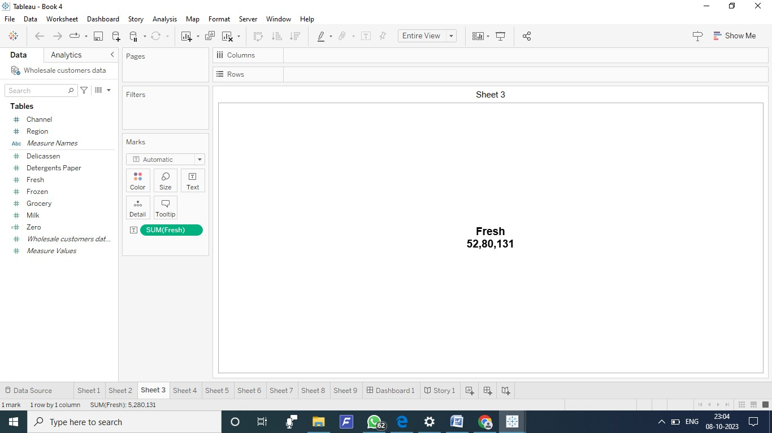

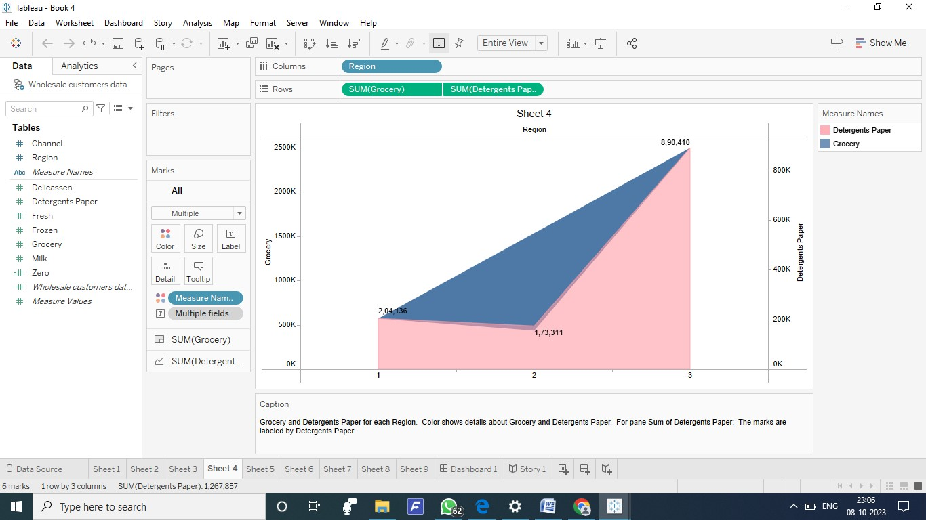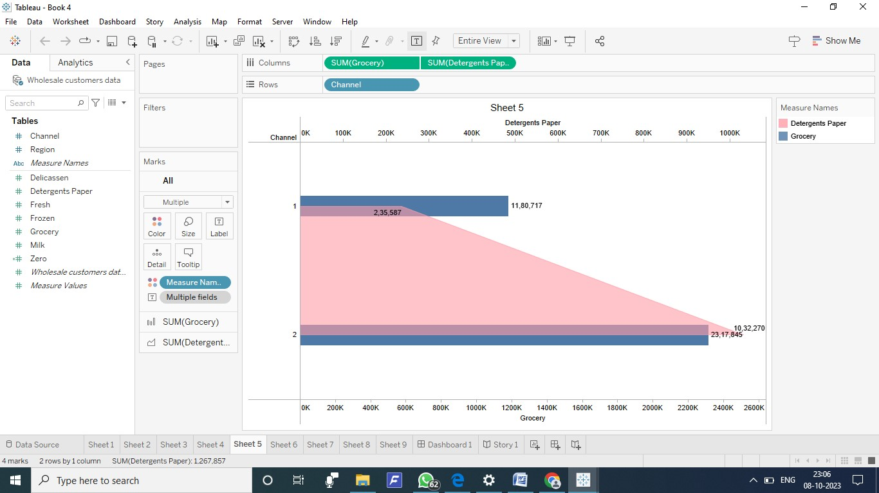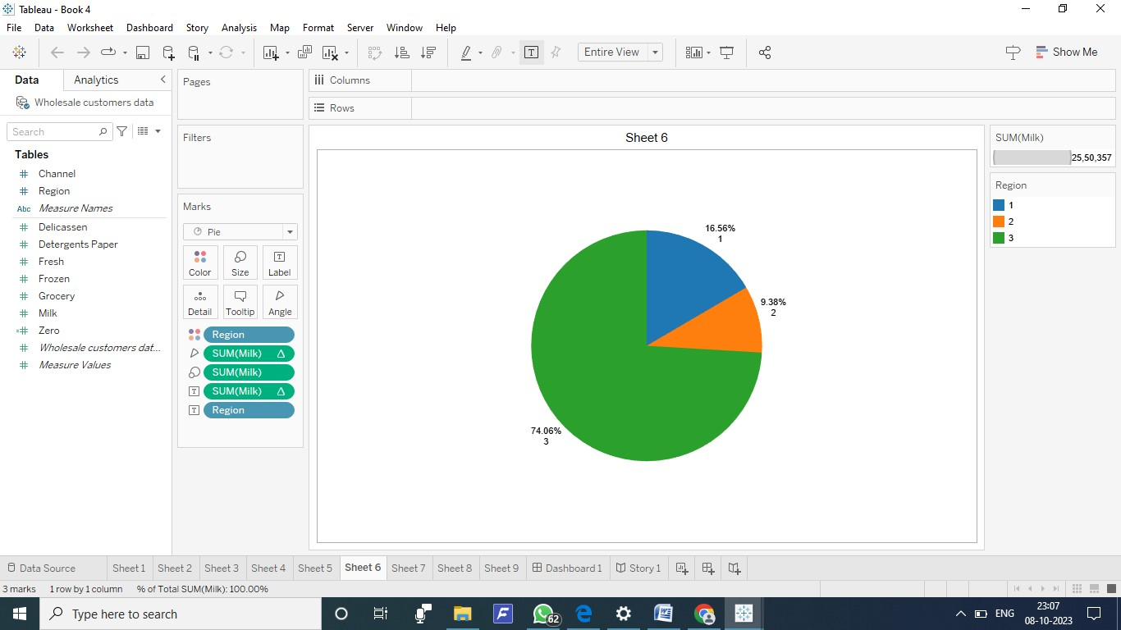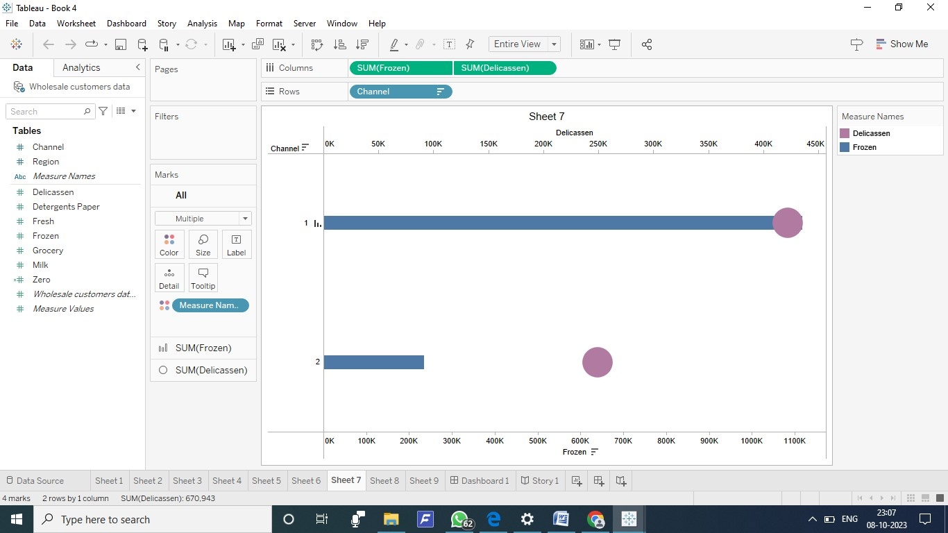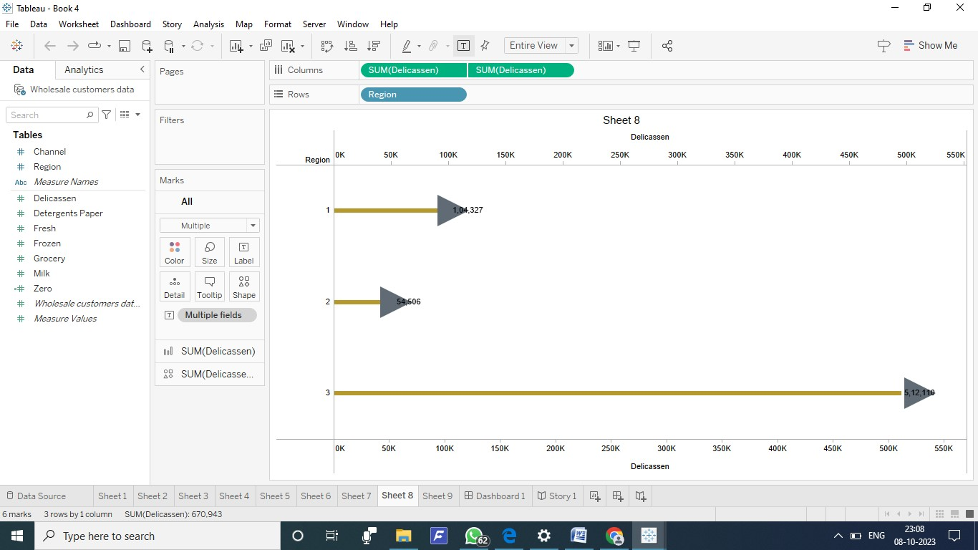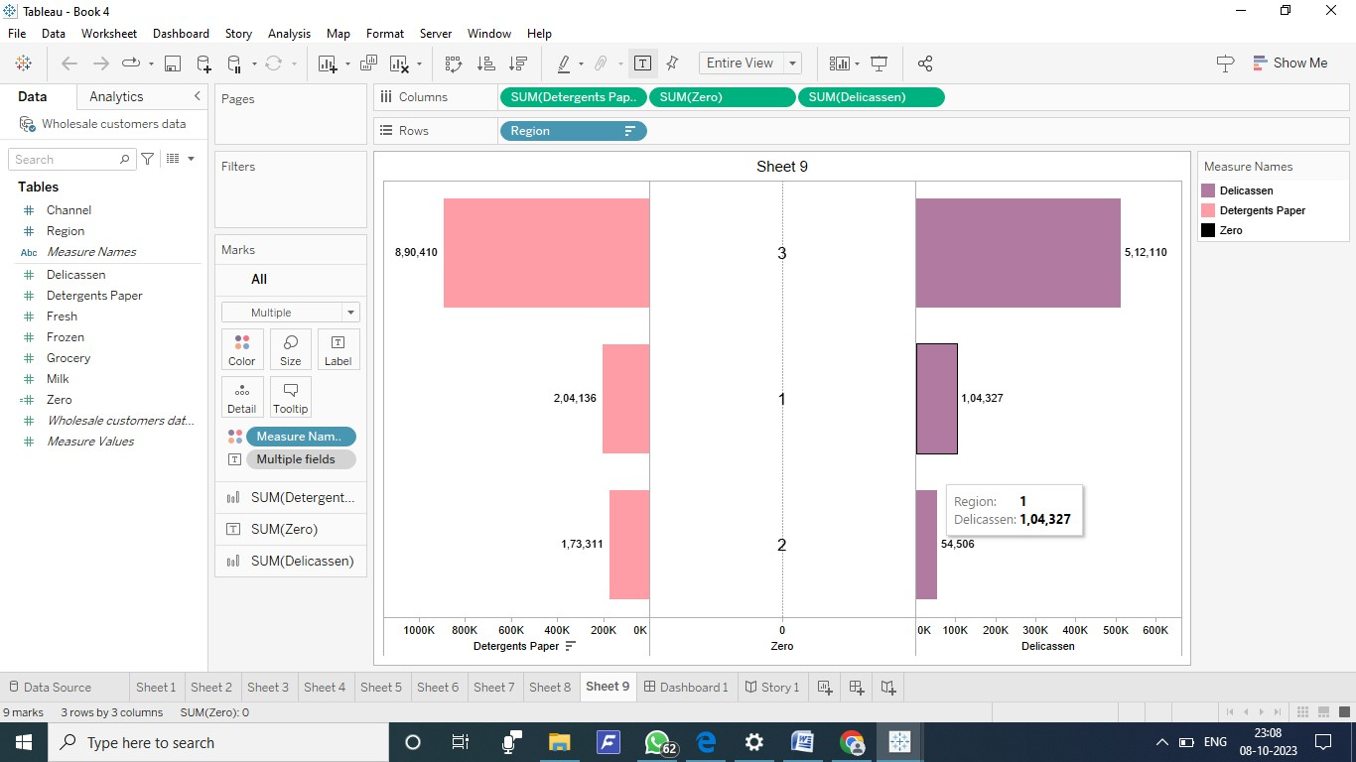

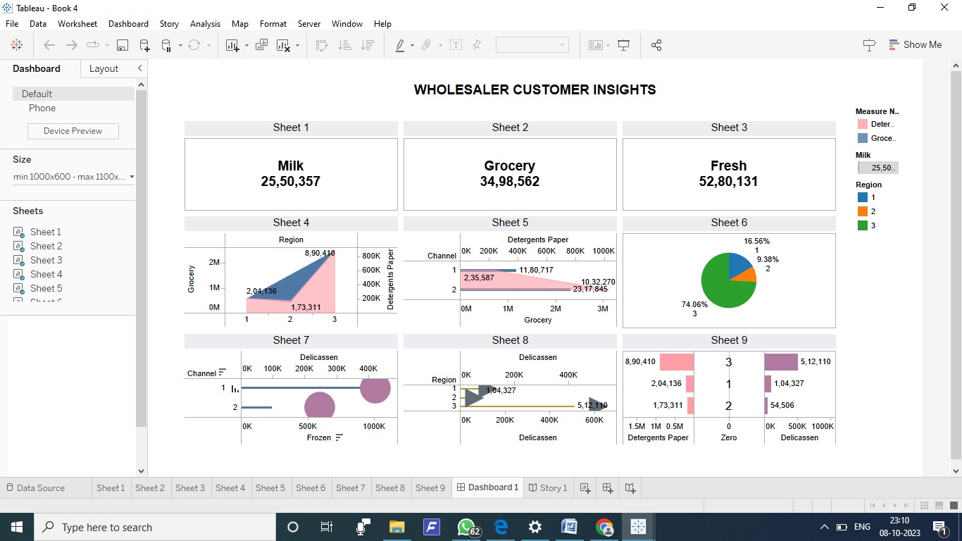

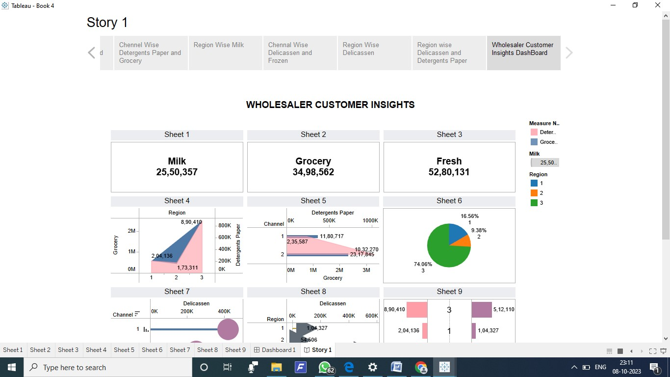

1. ADVANTAGES & DISADVANTAGES
   1. Advantages:

* Provides first-hand and specific data tailored to the research objectives.
* Allows businesses to gather unique insights directly from customers.
* Provides more control over the research process and data quality
  1. Disadvanatges:
* Time-consuming and expensive compared to secondary research.
* Requires resources for survey design, data collection, and analysis.
* A limited sample size may not represent the entire target market.

1. APPLICATIONS

This information can be used to improve the design of products or services, marketing campaigns, and customer service. Market research can also help companies to identify potential opportunities for growth or expansion, and to make informed decisions about the direction of their business

1. CONCLUSION

By harnessing the power of data and extracting meaningful insights, companies can make informed decisions, understand consumer needs, and identify growth opportunities. Effective market research analysis enables businesses to stay relevant, innovative, and successful in their respective industries

1. FUTURE SCOPE

Growth markets present opportunities for businesses to expand into new geographic areas or product categories. These opportunities increase the potential for rapid financial growth and benefit a company's existing operations through a more significant market share.